**Gartne**

**Mapping the Most Critical Customer Journeys**

Published 13 January 2022 - ID G00759324 - 7 min read

By Analyst(s): Financial Services Business Leader Research Team

[Initiatives: Financial Services Business Leadership and Strategy; Financial Services](https://www.gartner.com/explore/initiatives/overview/44817) Customer Experience, Talent and Delivery

Customer journey mapping is vital to addressing customer pain points but can often lack productive direction. This research helps financial services leaders who are responsible for customer experience prioritize their mapping efforts on the customer journeys that most affect the relationship.

Lập bản đồ hành trình của khách hàng là rất quan trọng để giải quyết các điểm khó khăn của khách hàng nhưng thường có thể thiếu phương hướng hiệu quả. Nghiên cứu này giúp các nhà lãnh đạo dịch vụ tài chính chịu trách nhiệm về trải nghiệm khách hàng ưu tiên các nỗ lực lập bản đồ của họ về hành trình của khách hàng có ảnh hưởng nhiều nhất đến mối quan hệ.

Journey mapping has long been an important way for financial services leaders to find and address customer pain points and improve the customer experience. These improvements can drive higher successful completion rates for interactions and reduce customer attrition, ultimately benefiting business growth at the financial institution. But journey mapping can require significant investments of organizational time, labor and resources, especially since there are a wide variety of customer journeys to potentially focus on. Financial services leaders need to be able to prioritize the right customer journeys to make best use of limited resources for journey mapping.

*A customer journey is a tool that helps marketers understand the series of connected experiences that customers desire and need — whether that be completing a desired task or traversing the end-to-end journey from prospect to customer to loyal advocate.*

Most firms use a combination of two sources of information to select customer experiences to improve with journey mapping. First, they can solicit customer feedback to identify where certain journeys are falling short. Second, financial services leaders can question frontline talent about the journeys that they feel need the most improvement. For example, call center staff can report on the issues they hear most often, or the issues they are least equipped to solve.

However, these sources have a few key drawbacks. They tend to find the pain points that cause the greatest annoyance or disturbance, but these are not always the issues that are most harmful to a customer relationship. Moreover, they can miss the pain points that occur before the customer directly interacts with the provider. That is, some potential customers could be turning away from the bank before they have the opportunity to either give feedback or interact with an employee.



In other words, if financial services leaders only use customer feedback and frontline observations, they could miss out on potential customers without ever knowing why. To avoid these drawbacks, financial services leaders should assess the effect of each journey on their relationships with customers and prospects, rather than just referring to traditional negative feedback, when prioritizing their customer-journey-mapping efforts.

Targeting Journeys by Effect on Revenue Actions

To help financial services leaders find the most critical interactions to target through journey mapping, Gartner organized customer interactions and needs into six broad categories (see [Bank Customer Need and Channel Analyzer](https://www.gartner.com/document/code/749326?ref=authbody&refval=)):

* Buying or selling a nonfinancial asset
* Planning for a personal or family event
* Conducting business or retirement planning
* Responding to an unexpected incident
* Paying an unexpected expense
* Dealing with income loss

In the 2020 Gartner COVID-19 Customer Experience Survey,1 we also asked customers if, following their interaction, they had done (or were likely to do) one of the following:

* Shop for a new provider
* Switch to a new provider
* Decrease the amount of savings or borrowing with their provider
* Increase the amount of savings or borrowing with their provider
* Close existing accounts or products with their provider

**Gartne**

■ Open new accounts or products with their provider

Gartner organized these statements into positive and negative revenue customer actions. To isolate the journeys that represent the biggest threats and opportunities for financial institutions, Gartner compared each to day-to-day banking in terms of its correlation with revenue-affecting customer actions (see Figure 1). 1

Figure 1 : Predictive Value of Interactions for Actions

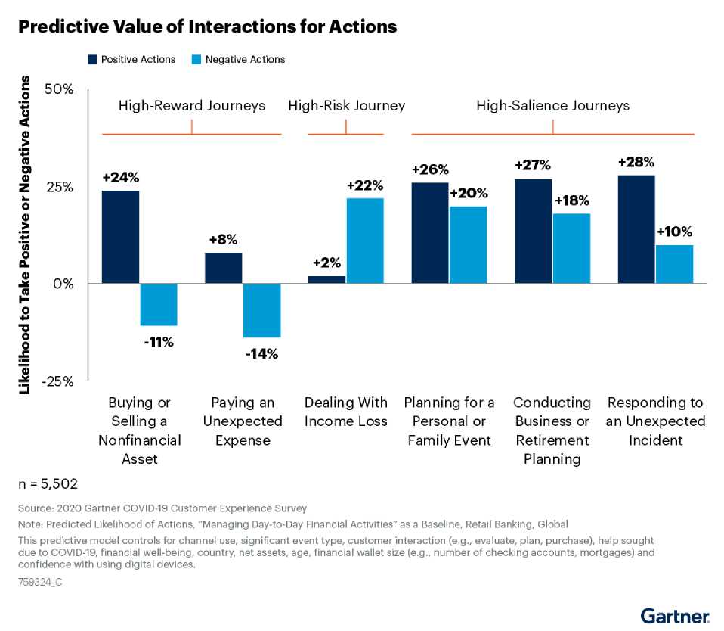

High-Reward and High-Risk Customer Journeys

Our analysis indicates that the journey a customer is going through can have a significant effect on that customer's relationship with a provider — either for better or for worse. For example, identifying and engaging customers after they have bought or sold a nonfinancial asset is likely to lead to a positive outcome for providers. Because this is a situation involving cash flow, it is perhaps unsurprising that such journeys typically lead to positive outcomes for banking providers.



Conversely, customers who engage with their financial provider to deal with income loss are significantly more likely to take negative revenue actions, such as drawing down accounts or switching providers, than customers managing their day-to-day finances. These are fraught interactions for customers and their providers, likely due to the instigating loss of income, a problem that is difficult or even infeasible for banks to solve. However, there are still actions that providers can take during these journeys, which will help achieve positive outcomes:

* Proactively acknowledge and address customer needs beyond the services the firm can provide.
* Show customers how they're benefiting from the firm's effort and expertise.
* Consider partnerships and embedded financial relationships with service providers that can help customers in ways banks can't.

High-Salience Customer Journeys

When customers are planning for a personal or family event, conducting business or retirement planning, or responding to an unexpected incident, the effect of their journey on their relationship with their provider is less straightforward. They are significantly more likely to take both positive and negative revenue actions with their provider than they would be if they were just managing their day-to-day finances. This means that these high-salience journeys are significant opportunities for financial institutions, but only if they are able to meet customer needs for these interactions. Overall, customers who engage in these interactions with their providers are over 25% more likely to take revenue­positive actions than those handling day-to-day banking, but are also 10% to 20% more likely to take revenue-negative actions (see Figure 1). These are typically situations in which customers are considering their financial options, and where their journey with a provider can have an outsized impact leading to a positive or negative customer action.

For example, customers dealing with an unexpected incident, as well as those dealing with an unexpected expense or loss of income as detailed above, are likely to approach their financial providers in a distraught state of mind. Financial services leaders should ensure their customer experience for this journey does not make the mistake of focusing solely on empathy and quick resolution, as this approach can create a negative journey [experience. Based on Voice of the Customer: How Financial Services Providers Should](https://www.gartner.com/document/code/745165?ref=authbody&refval=) Respond to Customers Experiencing Unexpected Situations, providers should:



* Be clear about the difficulty of the request, even in the best channel.
* Generate accountability for resolution within the firm.
* Demonstrate prior knowledge of the customer.

Customers reaching out for help with planning for a personal or family event and conducting business or retirement planning often want timely advice. If providers wait until customers come to them for help with planning, they may miss their opportunities. Based on [How Helping Mass Affluent Customers With Retirement Creates Growth](https://www.gartner.com/document/code/745783?ref=authbody&refval=), providers should instead work to engage with customers earlier on in their journeys, before their needs are met elsewhere.

For retirement planning specifically, financial services leaders should:

* Target customers before they receive access to employer-sponsored plans with competitor institutions.
* Broach the retirement conversation with customers as they approach their late 20s to early 30s to support long-term relationship building and growth.
* Maintain consistent conversations with older customers who have already retired to avoid issues that may cause them to seek help elsewhere.

High-salience journeys originate with complex situations like retirement and family events, and they may not be equally serviceable in every channel. In these cases, financial services leaders should:

* Communicate best-fit channels early in the interaction by setting expectations and nudging customers toward channels better-suited to their experience.
* Make it easy for customers to access best-fit channels once providers have identified these options.

■ Invest resources in natural channel strengths.



Finding and Mapping Your Firm's Priority Journeys

Of the customer journey groups explored here, financial services leaders should focus on mapping the highest-reward journeys, buying or selling nonfinancial assets, and paying an unexpected expense, first, if they haven't already. After that, the most important journeys to map largely depend on the firm's target customer segments. Leaders can look to either mitigate journeys that typically have negative customer actions, or ensure that high- salience journeys trend toward positive customer actions for their organization.

To help, financial services leaders should use Gartner's Bank Customer Need and Channel [Analyzer to find the most salient and important customer needs for their institution's most](https://www.gartner.com/document/code/749326?ref=authbody&refval=) critical customer segment, which the tool can narrow down by age, assets, financial health and other factors. Once target journeys are decided, financial services leaders should review [The Key Steps to Begin Customer Journey Mapping](https://www.gartner.com/document/code/755690?ref=authbody&refval=) to avoid common pitfalls. These tools can help to ensure that more journeys have positive outcomes for both the provider and the customer.

*by Uri Lerner*

**Recommended by the Authors**

[Bank Customer Need and Channel Analyzer](https://www.gartner.com/document/code/749326?ref=authbody&refval=) [The Key Steps to Begin Customer Journey Mapping](https://www.gartner.com/document/code/755690?ref=authbody&refval=)

[Voice of the Customer: How Financial Services Providers Should Respond to Customers](https://www.gartner.com/document/code/745165?ref=authbody&refval=) Experiencing Unexpected Situations

[How Helping Mass Affluent Customers With Retirement Creates Growth](https://www.gartner.com/document/code/745783?ref=authbody&refval=)

**Endnotes**



1 This research is based on the 2020 Gartner COVID-19 Customer Experience Survey. The survey was conducted via an online panel from September 2020 through October 2020, collecting responses from 5,502 retail banking respondents. Quotas and weights were applied for age, gender, region and income at the country level, so that the sample mirrors the distribution of the retail banking population. The results of this survey are representative of the respondent base and not the "global" retail banking population as a whole. The surveys were developed collaboratively by a team of Gartner researchers and quantitative analysts and were reviewed, tested and administered by Gartner's Research Data and Analytics team.

© 2022 Gartner, Inc. and/or its affiliates. All rights reserved. Gartner is a registered trademark of Gartner, Inc. and its affiliates. This publication may not be reproduced or distributed in any form without Gartner's prior written permission. It consists of the opinions of Gartner's research organization, which should not be construed as statements of fact. While the information contained in this publication has been obtained from sources believed to be reliable, Gartner disclaims all warranties as to the accuracy, completeness or adequacy of such information. Although Gartner research may address legal and financial issues, Gartner does not provide legal or investment advice and its research should not be construed or used as such. Your access and use of this publication are governed by [Gartner's Usage Policy](https://www.gartner.com/technology/about/policies/usage_policy.jsp). Gartner prides itself on its reputation for independence and objectivity. Its research is produced independently by its research organization without input or influence from any third party. For further information, see "[Guiding Principles on Independence and Objectivity](https://www.gartner.com/technology/about/ombudsman/omb_guide2.jsp)."